TOC : MARCH 2026
- ACTIVITIES DIRECTLY BY THE CLUB

PUBLIC AWARENESS AND COMMUNITY ACTIVITIES AND CAMPS
Glaucoma walk conducted by TOC on March 8th Sunday as a part of world glaucoma awareness week. Flag off done by Sri V V Rajesh Mayor Trivandrum, and the chief guest was Mr Rajeev Devraj Editor Mathrubhumi news. Along with walk there was a flash mob and a Zumba dance. All the senior faculty of Trivandrum ophthalmic club participated in the program and there was awareness talk by most of them to the public was also there.
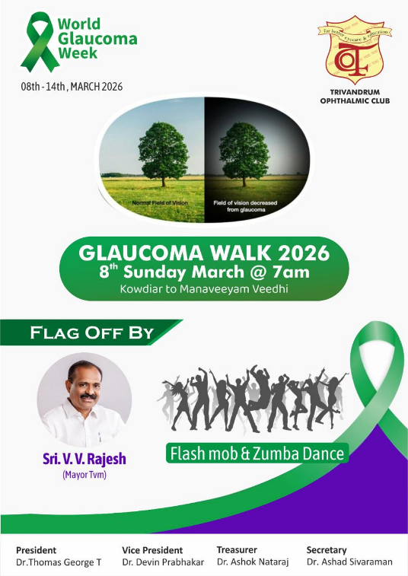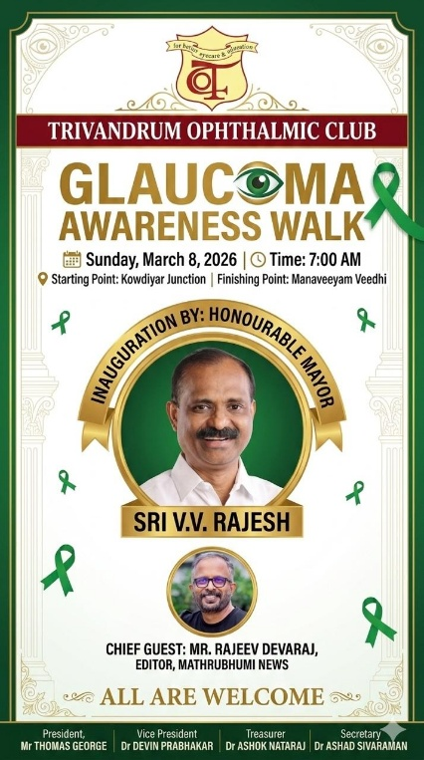
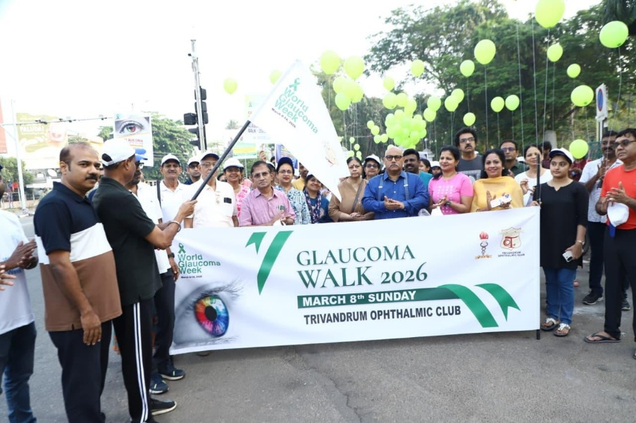

- ACTIVITIES BY INDIVIDUAL INSTITUTES OR MEMBERS

PUBLIC AWARENESS AND COMMUNITY ACTIVITIES
Statewide webinar was conducted by Indian Medical Association as a part of world glaucoma week on Tuesday 0th March 2026 at 8am. Topic of discussion was Glaucoma Demystified by Dr Kiran Gopalakrishnan. Inauguration was done by Dr M N Menon President IMA Kerala State Branch.
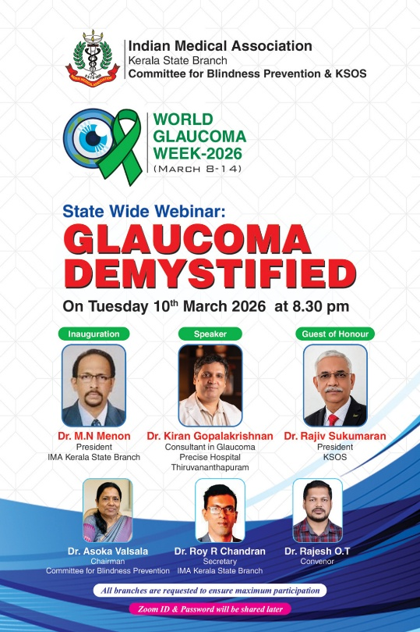

Gitanjali Eye Hospital conducted a world glaucoma week car rally from Trivandrum club to Shangumugham beach as a hit the road to raise the awarenesss for the silent thief of sight.
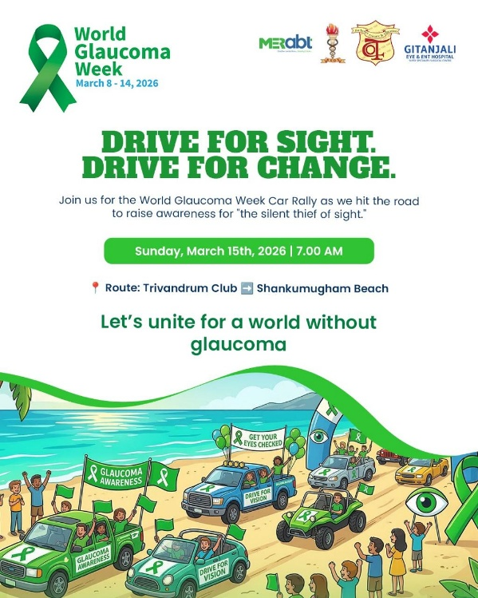
Free eye check-up and IOP screening camp for the public including the free eye pressure testing, optic nerve evaluation and expert glaucoma counselling conducted frm March 8th to 14th by
- Divya Prabha Eye Hospital, Kumarapuram
- Sreenetha Eye Care, Bakery junction
- Chaithanya Eye Hospital Kesavadasapuram
- Aradhana Eye Institute Manacaud and Vattapara
- Dr Prem’s Eye Hospital Vanchiyoor
- Precise Speciality Eye Care PMG
- KIMS Health ophthalmology department
- Gitanjali Eye and ENT Hospital Vazhuthacaud
- Devas Eye Crae Manacaud
Gitanjali Eye and ENT Hospital conducted an awareness talk focusing on the early diagnosis and long-term management of glaucoma by Dr Sreenath for the public along with free eye check-up.
Gitanjali Eye and ENT Hospital conducted eye pressure and vision testing for employees to ensure workplace wellness and safety.
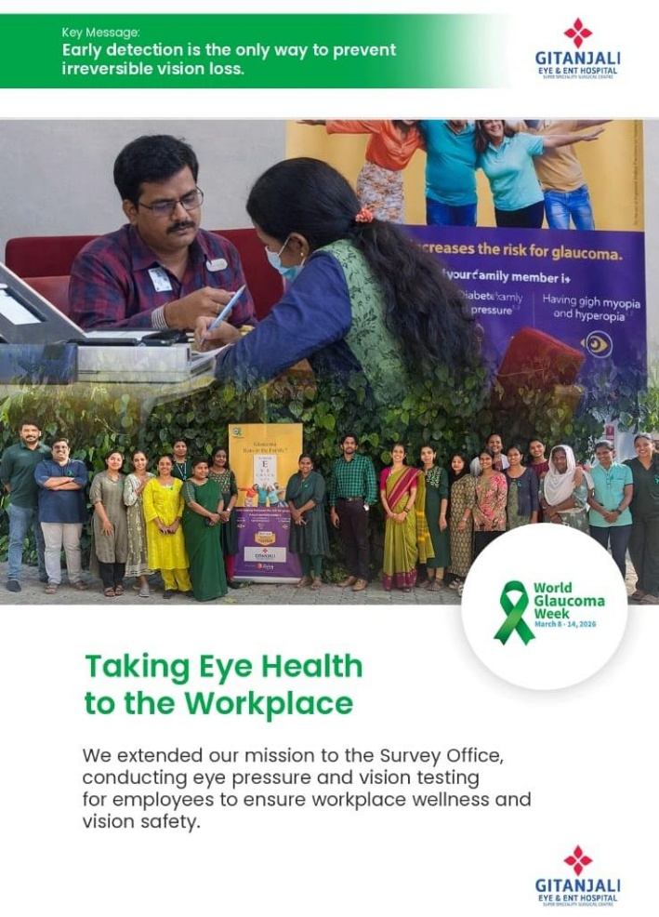

Dr Veena Viswam conducted an awareness talk in Akashavani Trivandrum on 9th March 2026 at 12.40pm.

