TOC : FEBRUARY 2026
- ACTIVITIES DIRECTLY BY THE CLUB
PUBLIC AWARENESS AND COMMUNITY ACTIVITIES AND CAMPS
As part of the KSOS Presidential Project “Anbu”,Regional Institute of Ophthalmology (RIO TVM) and Sreenethra Eye Care, under the aegis of Trivandrum Ophthalmic Club (TOC), conducted an Eye Camp at Developmental Centre for Mentally Retarded Children Murinjapalam, Thiruvananthapuram on 20th February and examined 47 patients
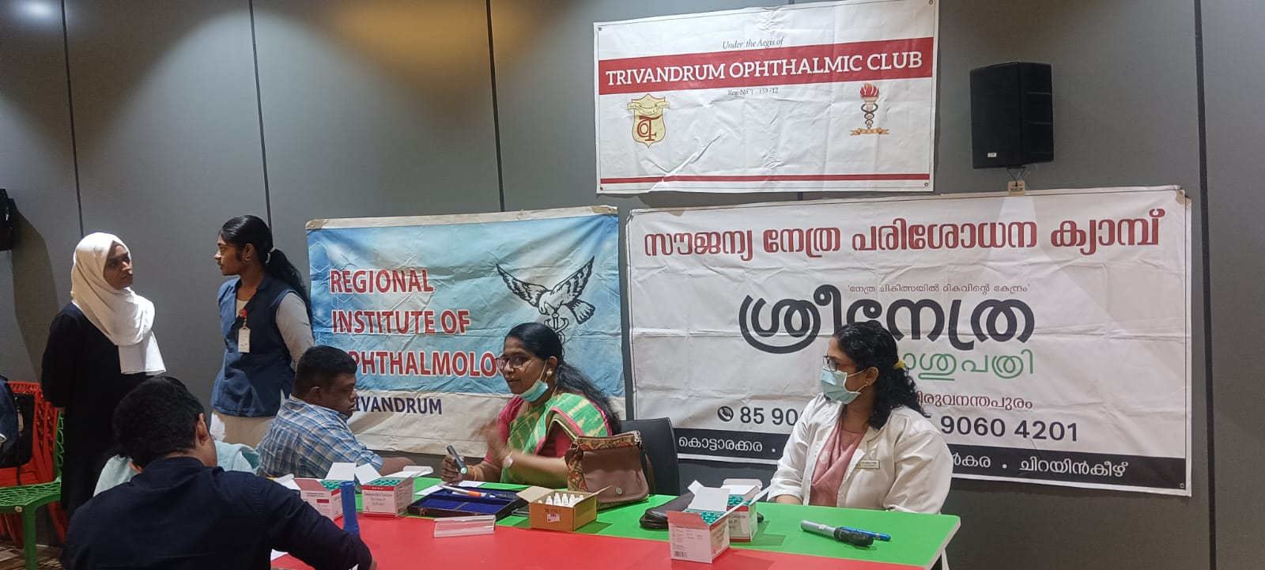
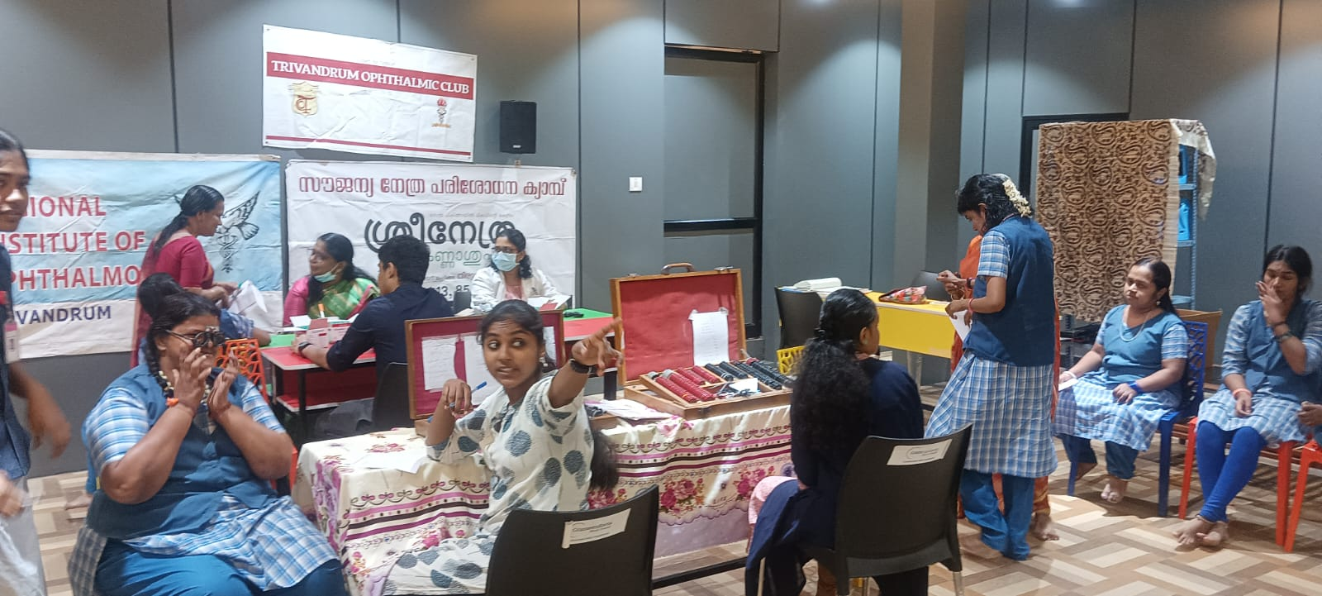

- ACTIVITIES BY INDIVIDUAL INSTITUTES OR MEMBERS
SCIENTIFIC ACTIVITIES UNDER THE AEGIS OF CLUB AND OR KSOS
PRECISION 2026 conducted by Precise speciality eye care under TOC &KSOS on 8th February Sunday. Sessions included were Cornea & cataract, Retina & Nruro- ophthalmology, Glaucoma and PG quiz. The highlight of the academic feast was signature oration by Dr Lingam Gopal on Retina Imaging – past, present and future.
As part of PRECISION 2026, the Postgraduate Quiz Competition was conducted in the afternoon session. Postgraduate students representing various medical colleges and Eye hospitals from Thiruvananthapuram and Kollam participated with great enthusiasm.
Prize – Dr Deepthi Roy S, RIO, Thiruvananthapuram
Second Prize – Dr Anjana P, Chaithanya Eye Hospital, Thiruvananthapuram
Third Prize – Dr Parvathi S Nair, Chaithanya Eye Hospital, Thiruvananthapuram

