TOC –QUARTERLY REPORT (APRIL TO JUNE)

Section 1 MONTHLY MEETINGS
- MONTHLY MEETING APRIL 26
  - TOC monthly meet conducted on 29th April 2026
  - Venue was Residency Tower Trivandrum.
  - Number of attendees was 42
  - Dr A Syed Mohideen Abdul Khader chief consultant vitreo retinal services Aravind Eye Care Tirunelveli was the main guest speaker and the talk was on” From Trauma to vision rescue managing intra ocular foreign bodies”
  - Second talk was on Ranibizumab biosimilar in Neovascular age related macular degeneration by Dr Ashwin P R. .

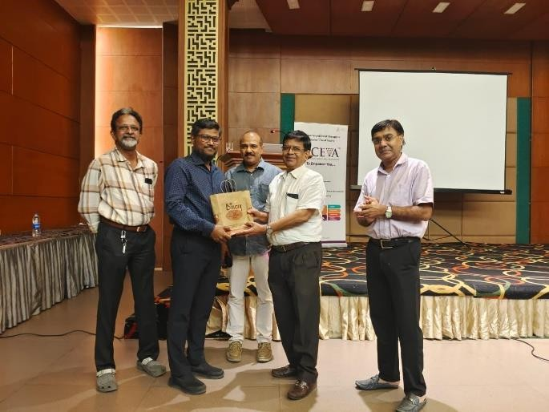
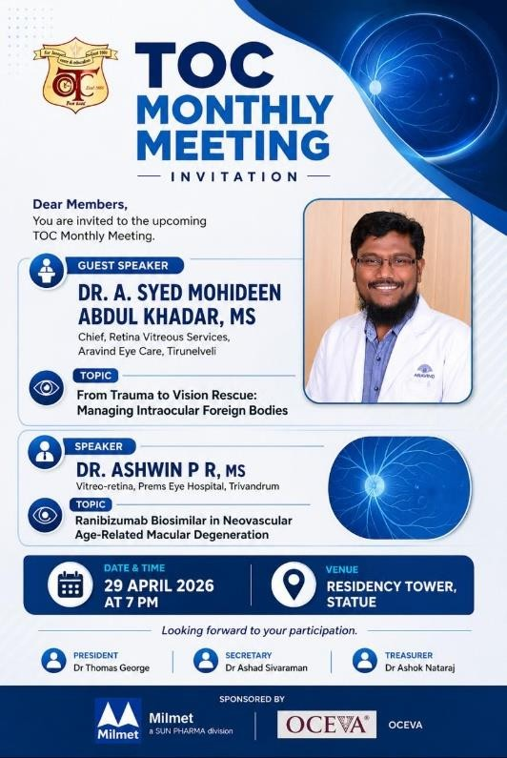

- MONTHLY MEETING MAY 2026

  - TOC monthly meet conducted on 21st May 2026 at
  - Venue was Apollo Dimora Trivandrum.
  - Number of attendees was 42
  - Guest speaker was Dr John Davis Akkara, and the first talk was on “AI in ophthalmology”, second talk was on “Smart phones in ophthalmology”.
  - We felicitated
The faculty of the last PG training program for their contributions and efforts AIOS International hero of India-- Dr Minu Mathen
Recipient of Dr AM Gokhale oration award 2026 – Dr Unnikrishnan Nair,
First runner up in the best poster competition and the LOC award for best case presentation at the OPAI Conference – Dr Aparna.
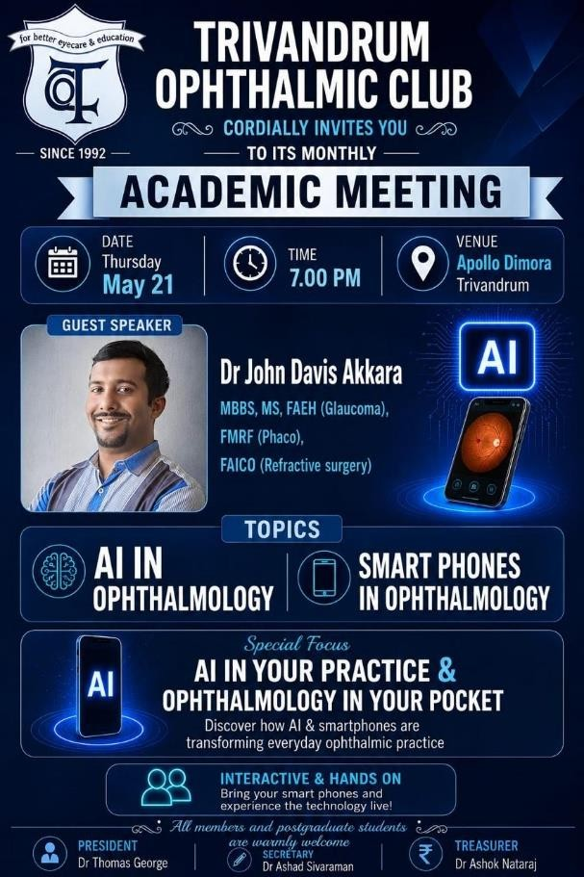
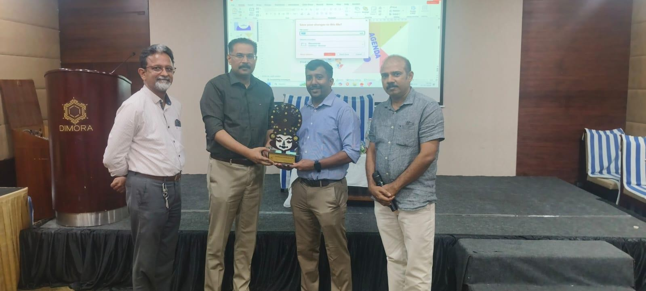

3.Monthly meeting June 2026

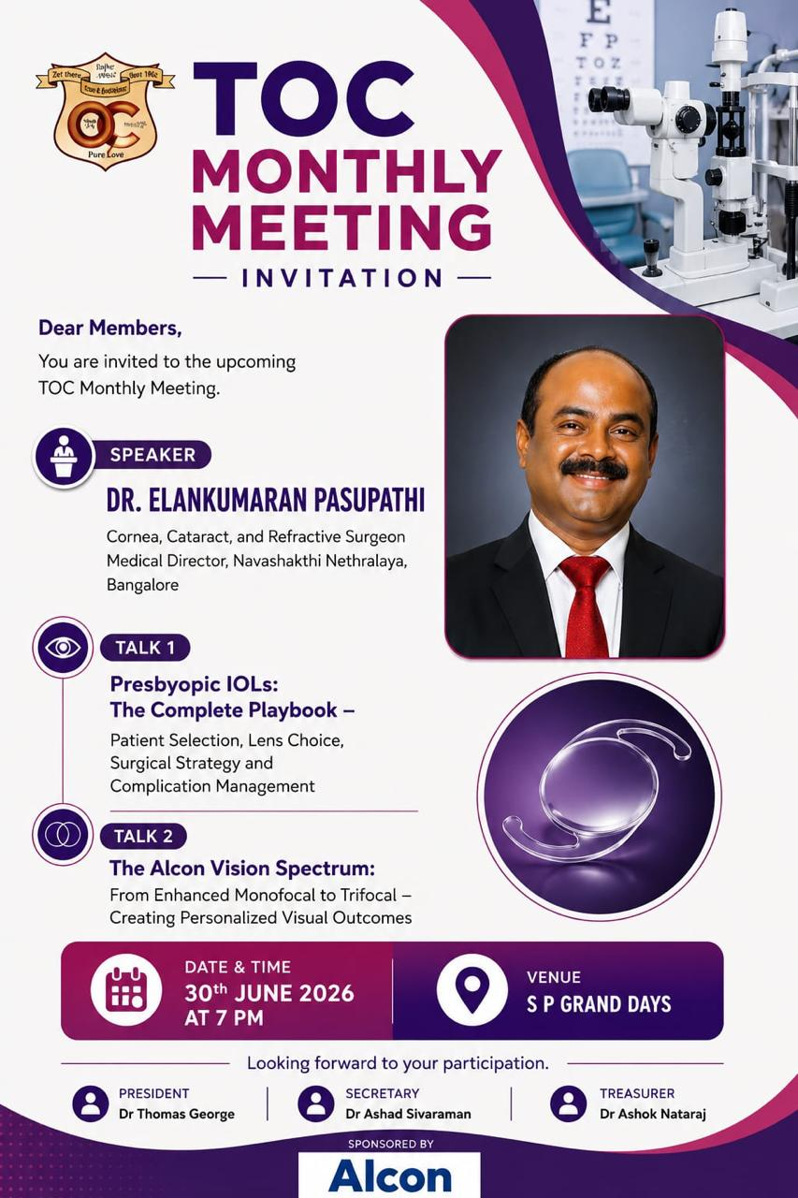

Section 2 Other Academic Activities
CMEs

1.Gokulam medical college conducted a CME on 12th April 2026 at SP Grand Days
Focus was on challenging ophthalmic cases in Paediatric ophthalmology and Refraction, Cataract, Neuro ophthalmology and ocular inflammation.Number of attendees was 68

  - 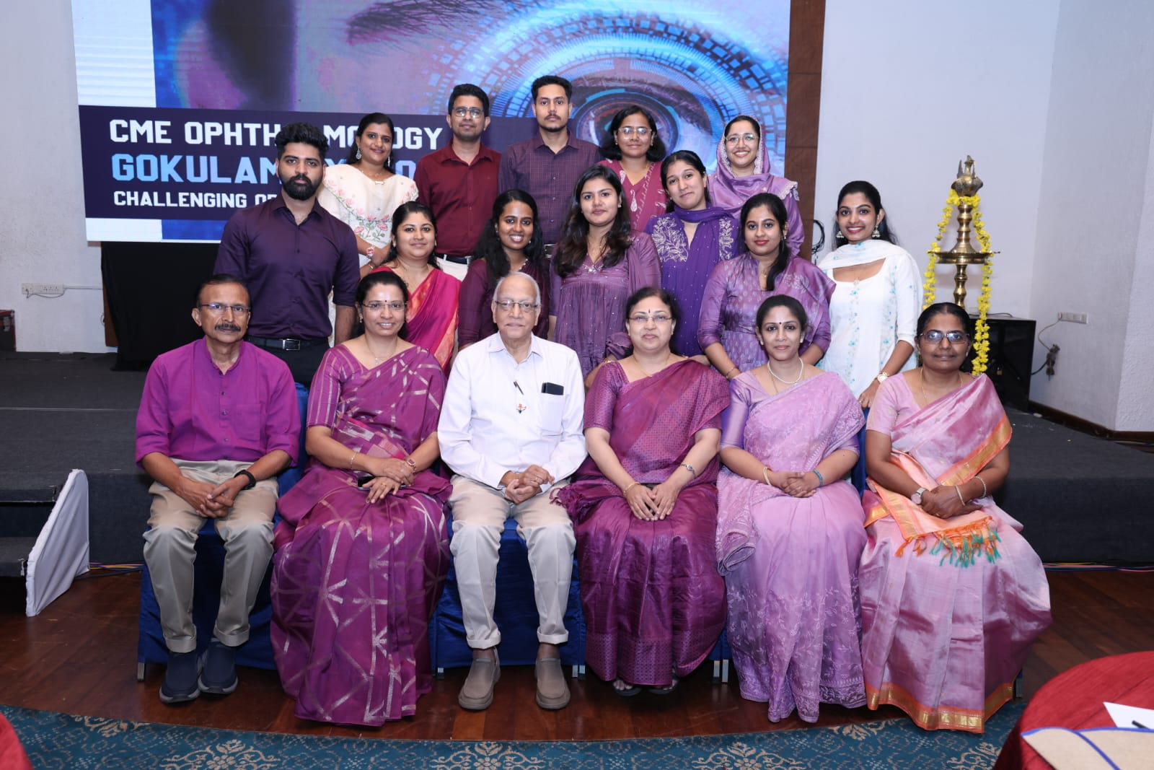
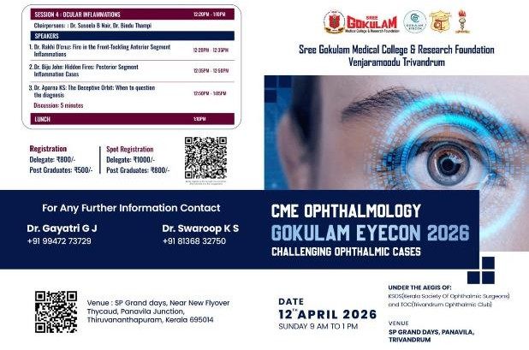
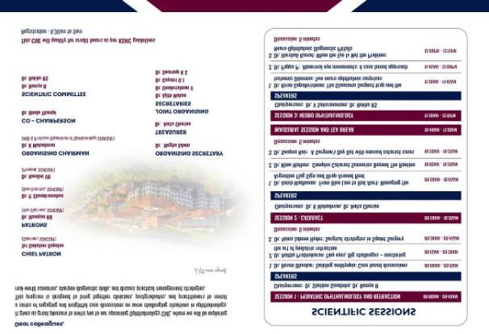
2.SACON 26 conducted by Sreenethra Eye Care on 17th May 2026 at Hyatt Regency Trivandrum, based on the theme “Mistakes, Misses and Masterstrokes What guidelines and textbooks don’t tell us”.
  - This meeting brought together the eminent national and state experts like Dr Vishali Gupta, Dr Krishna Das, Dr Meenakshi Swaminathan, Dr Namrata Sharma, Dr Santhosh Honavar, Dr Mahesh G, Dr Geetha Iyer, Dr Bindhu S Ajith, Dr Devendra Maheswari, Dr Fairoz, Dr Maya Hada, Dr Neena R, Dr Shishir Varghese, Dr Anila George in various specialities like Glaucoma, Uvea and Retina,Orbit and
Oculoplasty, Paediatric ophthalmology and Squint, Cornea and Ocular surface.
  - The most attractive session was skill transfer stations. The attendees were 120

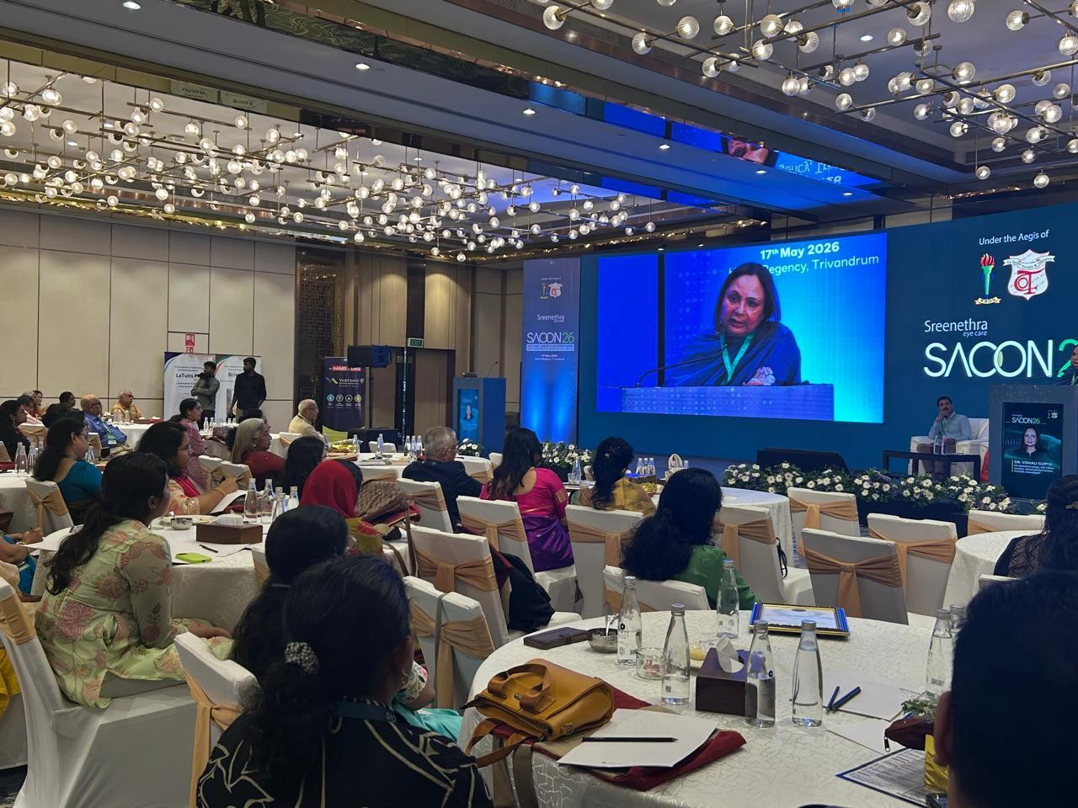
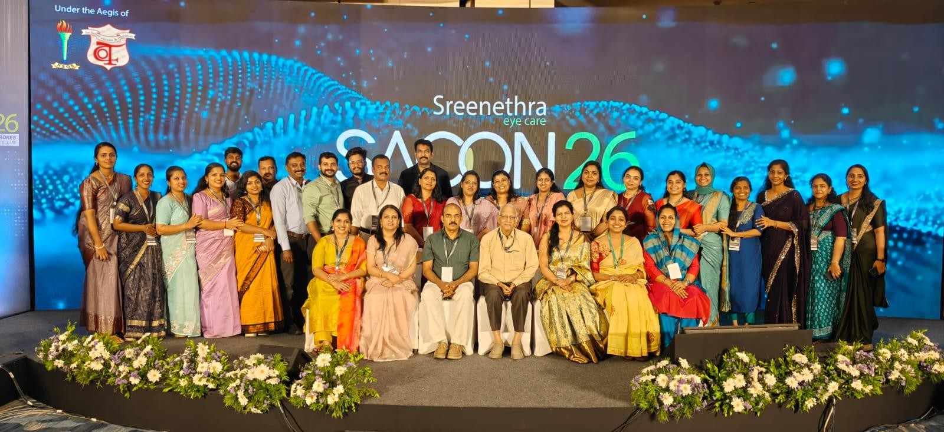

3.ANANTHANAYANAM 2026- Skills and Strategies simplified
conducted by RIO on 31st May at Hotel SP Grand Days from 8.30 am to 3.00 pm,
  - Focusing on the practical aspects of ophthalmology covering key areas of retina, glaucoma, cornea and application of AI.

  - CME aimed to strengthen the diagnostic clarity and surgical confidence through eminent speakers like Dr Mahesh G, Dr Unnikrishnan Nair,Dr Saikumar S J, Dr George Puthuran, Dr Anil Radhakrishnan, Dr Bini S T Dr Minu Mathen, Dr Anitha Balachandran, Dr Neethu Mohan, Dr Arup Chakrabarti, Dr Smitha Narayanan, Dr Rajiv Sukumaran.The number of attendees was 130.
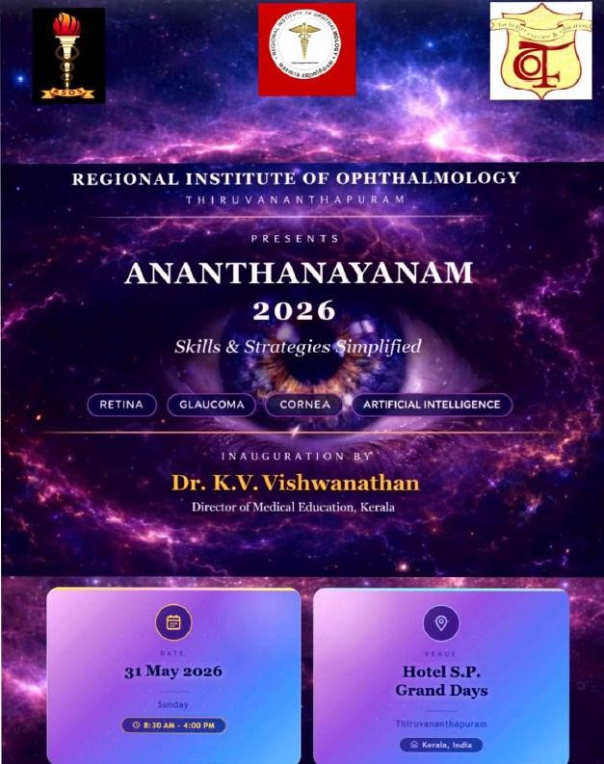
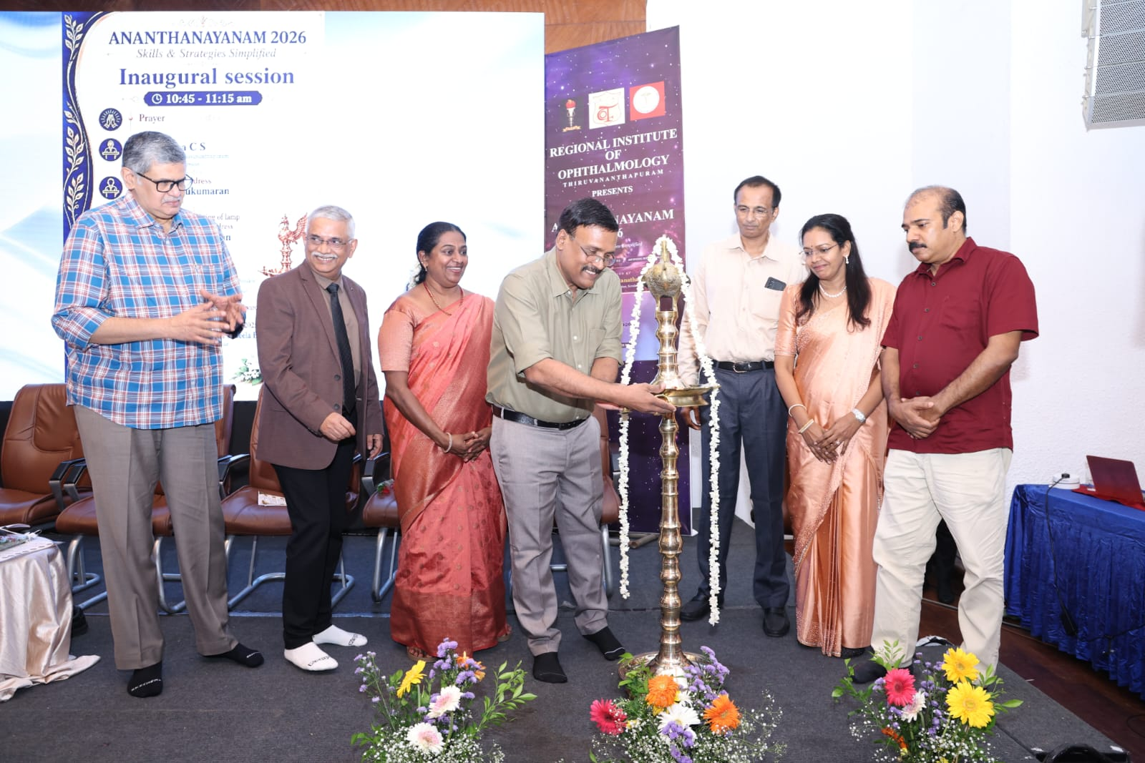

SECTION 3 CAMPS
N/A

SECTION 4 INDIVIDUAL AWARDS
  - AIOS International Hero of India Award --- Dr Minu Mathen
  - Dr A M Gokhale oration award 2026
Dr Unnikrishnan Nair
  - First runner up in the best poster and LOC Award for best case presentation at OPAI 26
Dr Aparna
  - PG teams from Chaithanya Eye Hospital performed excellently in the Big Q Brain Teasers All India Quiz
Team Nethra- secured 3rd prize Dr Anjna P & Dr Parvathy B Raj with Mentor Dr Aparna
Team Lumina – secured 5th prize Dr Shahana & Dr Parvathy S Nair, with Mentor Dr Femina Hashim.

SECTION 5
N/A

